Monday | Tuesday | Wednesday | Thursday | Friday
2 | 3 | 4 | 5 | 6
8:50 AM Email & Attachments  11:20 AM Assessment  12:50 PM Work Keys (appt. only) | 8:50 AM SMART Goal Writing  11:50 AM Basic Computers  2:50 PM FCA Interview Workshop | 1:20 PM Skills Assess/Career Exploration & Soft Skills  2:50 PM Online Applications | 8:50 AM Interview Workshop  11:20 AM Job Retention Essentials  12:50 PM Assessments*  1:50 PM Basic Computers  4:50 PM FCA Interview Workshop | 8:50 AM Assessments  9:50 AM Email & Attachments  1:50 PM Resume Maker
9 | 10 | 11 | 12 | 13
8:50 AM Resume Maker  12:50 PM Assessment | 8:50 AM SMART Goal Writing  11:50 AM Basic Computers  2:50 PM FCA Interview Workshop | 1:20 PM Skills Assess/Career Exploration & Soft Skills  2:50 PM Online Applications | 8:50 AM Interview Workshop  11:20 AM Job Retention Essentials  12:50 PM Assessments*  1:50 PM Basic Computers | 8:50 AM Assessments  9:50 AM Email & Attachments  1:50 PM Resume Maker
16 | 17 | 18 | 19 | 20
8:50 AM Email & Attachments  11:20 AM Assessment  12:50 PM Work Keys (appt. only) | 8:50 AM SMART Goal Writing  11:50 AM Basic Computers  2:50 PM FCA Interview Workshop | 1:20 PM Skills Assess/Career Exploration & Soft Skills  2:50 PM Online Applications | 8:50 AM Interview Workshop  11:20 AM Job Retention Essentials  12:50 PM Assessments*  1:50 PM Basic Computers  4:50 PM FCA Interview Workshop | 8:50 AM Assessments  9:50 AM Email & Attachments  1:50 PM Resume Maker
23 | 24 | 25 | 26 | 27
8:50 AM Resume Maker  12:50 PM Assessment | 8:50 AM SMART Goal Writing  11:50 AM Basic Computers  2:50 PM FCA Interview Workshop | 1:20 PM Skills Assess/Career Exploration & Soft Skills  2:50 PM Online Applications | 8:50 AM Interview Workshop  11:20 AM Job Retention Essentials  12:50 PM Assessments*  1:50 PM Basic Computers | 8:50 AM Assessments  9:50 AM Email & Attachments  1:50 PM Resume Maker
30 | 31
8:50 AM Email & Attachments  11:20 AM Assessment  12:50 PM Work Keys (appt. only) | 8:50 AM SMART Goal Writing  11:50 AM Basic Computers  2:50 PM FCA Interview Workshop
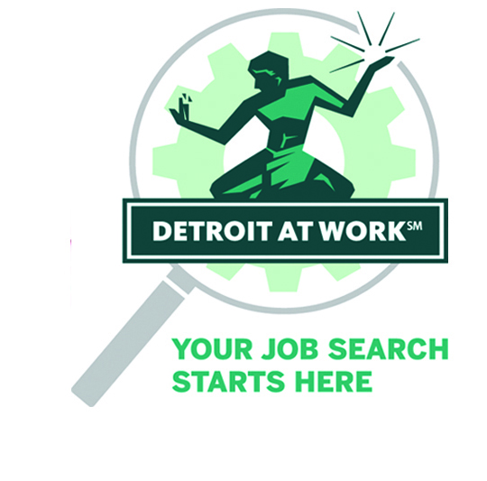
MEYERS CAREER CENTER CALENDAR
March 2020
18100 Meyers Rd. Detroit, MI 48235
313-962-WORK (9675) | DetroitAtWork.com
Career Advisor Walk-ins:
Monday – Friday, 8:30AM – 10:45AM
Introduction to Services and Recruitment Events:
Monday – Friday
Check-in: 8:30AM Event: 8:50AM
Check-in: 12:30PM Event: 12:50PM
Resource Room: Monday – Friday: 8:00AM – 4:30PM
Thursday extended hours: 8:00AM – 6:30PM

Traducción de currículum al español con cita solamente.
Spanish translation resume by appointment only.
Note: Jobseeker workshops are free and open to all. Participation is first come, first served. Days and times are subject to change without notice.
Some seat availability restrictions may apply.

Introduction to Services  Brief introduction to Center’s services for first-time customers and their enrollment with the system. Walk-in customers welcome. First come, first served. Seating is limited. Proof of age, residence and authorization to work in the U.S. required. MI State ID and SS Card are the preferred documents (please see sidebar for other acceptable documents).  Email and Attachments  Learn how to set up a free email account and how to prepare and send an email. You will also learn how to attach and send files electronically, like a resume and cover letter, so you don’t miss out on job opportunities.  Resume Maker  Tired of sending your resumes and getting no response? Learn how to create a resume that provides accurate and needed information in a recognized format. Hands-on staff assistance and computer resources provided.  Job Retention Essentials  Finding a job is the first step. Keeping that job and advancing are the next steps. Learn what employers want from employees and strategies for improving your employment status. Understand how to apply these strategies to your current or future job.  Assessments*  Career Cruising: Guided online, interactive assessment to identify the career that matches your interests and skills. CASAS: online test assesses English and Math skills. You will be provided with personalized feedback to help you understand – and apply – the results to your future plans.  *Note: You must have completed an orientation session and be active with one of our Detroit centers prior to participating in this workshop. Please arrive 15 mins prior to assessment time. | Online Applications  Avoid pitfalls and feel comfortable navigating job boards and company websites when applying for jobs electronically. Participants must have an email address and a resume in electronic format.  Interview Skills  Series of tips to improve your skills during interviews. Learn techniques that will turn your natural nervousness into confidence. You only have one chance to make a good first impression! A good resume gets you in the door, but a successful interview will get you the job.  Basic Computer  Fundamentals of using the computer, including Microsoft Word and Internet Basics. Learn to navigate between programs.  Work Keys (Appointment Only)  Assessments measure the workplace skills that can affect job performance. Successful completers can earn a National Career Readiness Certification (NCRC). Testing is done by appointment ONLY.  Individual Career Advisement  Meet individually with a career advisor to discuss employment goals and potential training options, your next steps, and to review your resume for potential updates and quality improvement. Customers are asked to bring their resume. Orientation is required for customers to register for career advisement services.  Recruitment Event  Partnering employers recruit for specific job openings.  Open to walk-in, first-time customers as well as registered customers. Seating is limited. Proof of age, residence and authorization to work in the U.S. required. MI State ID and  SS Card are the preferred documents.
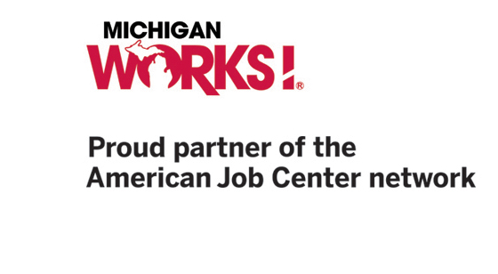
Detroit at Work Career Centers are operated by Detroit Employment Solutions Corporation, a Michigan Works! Agency. They are located throughout the city of Detroit and provide jobseekers with a wide range of FREE employment services, including job placement, career counseling, workshops, and access to training opportunities. To learn more about how Detroit at Work can help you find your new career, please visit DetroitAtWork.com.

An equal opportunity employer/program. Supported by the State of Michigan, Talent Investment Agency.
Auxiliary aids and services available upon request to individuals with disabilities. 1-800-285-WORK. TTY: 711.

Please see the list below of acceptable
documents for registration.
Proof of Age
Please bring in one from the list below
- Birth Certificate
- Driver’s License
- State Identification
- Official Government ID
Proof of Right to Work in the U.S.
Please bring in one from the list below
- Social Security Card
- Birth Certificate
- Alien Registration Card (I-94)
- Naturalization Certificate
- Resident Alien Card
- Passport
Proof of Michigan Residency
Please bring in one from the list below
- Driver’s License/State ID
- Utility Bill (with name and address)
- Rent Receipts (with name and address)
Dislocated Worker Documents
If you have any of these documents, please bring them
- Unemployment Insurance Records
- Pay Check Stubs
- W-2 and/or tax returns
- Notice of Layoff
- DD214
- Notice of Closure of Plant, Factory, or Business

Note: If possible, we recommend that you bring a flash drive to workshops to save your work. They are available at any office supply store, drug store, etc. Inexpensive flash drives work as well as more expensive models.

Detroit at Work Career Centers are operated by Detroit Employment Solutions Corporation, a Michigan Works! Agency. They are located throughout the city of Detroit and provide jobseekers with a wide range of FREE employment services, including job placement, career counseling, workshops, and access to training opportunities. To learn more about how Detroit at Work can help you find your new career, please visit DetroitAtWork.com.
An equal opportunity employer/program. Supported by the State of Michigan, Talent Investment Agency. Auxiliary aids and services available upon request to individuals with disabilities. 1-800-285-WORK. TTY: 711.

